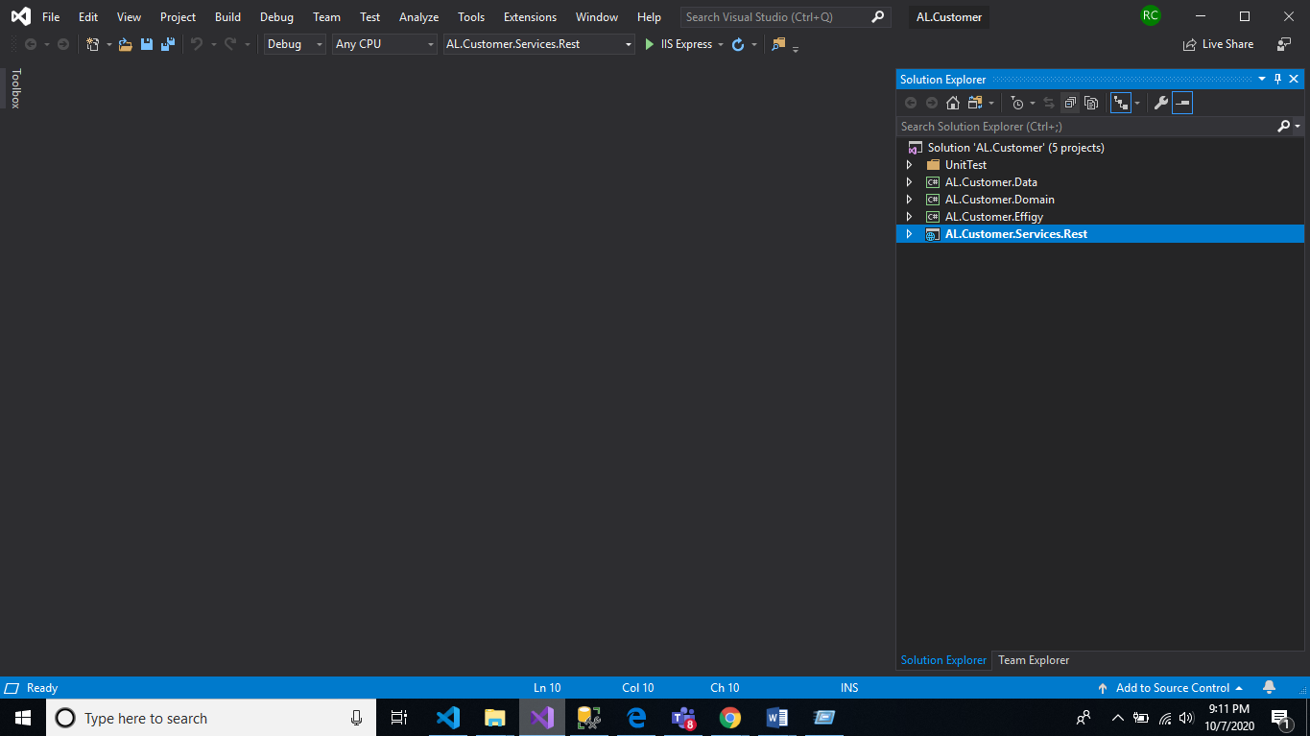

1. **AL.Customer.Services.Rest**: This is an Api Layer . Where the call gets landed when we get an request. As this is a controller layer. Here we wont be doing any business or DB logic. We will send the call to **AL.Customer.Domain.**

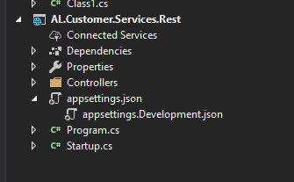

* **Controller** is the folder where we have controller classes with attribute route.
* **Appsetting.json** is the place where we have added our connection string. Going forward we will **AppsettingDev.json,** **AppsettingQA.json, AppsettingUAT.json** files . So for every deployment region it will have different file.
* **Startup.cs file** : We register our DI . And make a Dependency reference between Interface and Class file. Which is used in project. Again I haven’t added but all Generic Authentication ,Service Registery and global exception will be handled here in ConfigureServices.

1. **AL.Customer.Effigy:**  This is a model Layer. As we have Database model which is implemented at data layer . But it is not good to share that small model to the outer world. So we will have this model which will act as a view model for all the api request coming to Domain Layer .



1. **AL.Customer.Domain:**  This is a domain layer where we have one strict guild line. Do not make connection to any database . This is just a business logic /Validation implementation layer. Where any call comes from controller while either have **business logic**, **Validation Logic, DB model to View model mapper logic.** And after that call will be migrated to **AL.Customer.Data.**

In this layer again we have proper folders with Service and interface segregation.

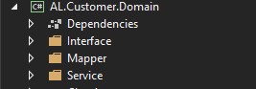

1. **AL.Customer.Data:** This is a layer where we have implemented repository pattern.And also we make a connection to Sql server and get data.

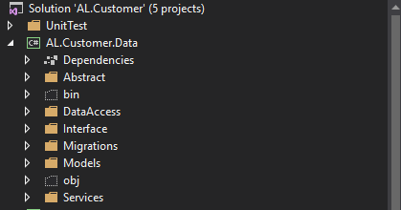

I have written xunit test case only for Service Layer . If required we can write for all layers.

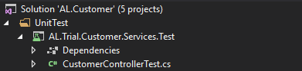

Note:

SQL Credentials for the host sever are listed below:

|  |  |
| --- | --- |
| URL | [**https://member5-2.smarterasp.net/account/loginform?go=1&w=1366&cplang**](https://member5-2.smarterasp.net/account/loginform?go=1&w=1366&cplang)**=** |
| User Name | rakeshdubai1989 |
| Password | Rakesh@1234 |

Also:

|  |  |
| --- | --- |
| Server Name | SQL5059.site4now.net |
| Login | DB_A6863F_rakeshdubai1989_admin |
| Password | Rakesh@1234 |

